TITLE-Interactive Superstore

Sales Dashboard
Name | Anshika
Subject | DATA SCIENCE-TOOLBOX R-PROGRAMMING
Dataset | Sample - Superstore (9,994 records)
Tool | R Shiny, RStudio
Date | 5 May 2026


Objective
The primary objective of this project is to design and develop a fully interactive, multi-tab Sales Analytics Dashboard using R Shiny and the Sample Superstore dataset. The dashboard is intended to help business users and analysts explore sales performance, profitability, customer behaviour, and future sales trends - all through dynamic, filter-driven visualizations - without requiring any programming knowledge.
Specific objectives include:
- Visualize overall KPIs Total Sales, Profit, Orders, and Customers - through real-time value boxes.
- Analyse monthly sales trends and identify seasonal patterns.
- Compare profitability across product categories, regions, and customer segments.
- Examine the effect of discount levels on profit using scatter analysis.
- Identify top-performing products (sub-categories) and high-value customers.
- Generate a 12-month sales forecast using the ARIMA time-series model.
- Explore statistical relationships between Sales, Quantity, Discount, and Profit via a correlation heatmap.
Provide a searchable, paginated Data Table for granular record-level exploration.

Introduction
In today's data-driven environment, businesses rely on dashboards to convert raw transactional data into actionable intelligence. R Shiny is a powerful web-application framework built on top of R that enables the creation of interactive dashboards directly from statistical code. Unlike static reports, Shiny dashboards react to user inputs in real time - filtering, aggregating, and re-rendering charts instantly.
The Superstore dataset is a widely-used retail analytics dataset that simulates sales transactions from a fictional US-based retail chain. It contains 9,994 rows across 21 columns - covering order details, customer demographics, geographical information, and financial metrics. This dataset is ideal for practising sales analytics because it contains a realistic mix of product categories, regional variation, and discount structures.
This project combines shinydashboard for the multi-tab layout, plotly and ggplot2 for interactive charts, the forecast package for ARIMA-based time series forecasting, corrplot for the correlation heatmap, and DT for the searchable data table.

3. Tools & Technologies Used
R / RStudio | Primary programming environment for writing and running the Shiny application.
shiny | Core framework for building the reactive, server-driven web application.
shinydashboard | Provides the professional sidebar + header + body dashboard layout with value boxes and styled panels.
ggplot2 | Grammar-of-graphics library used to construct all base charts (bar, line, scatter, pie-equivalent).
plotly | Wraps ggplot2 objects with ggplotly() to add hover tooltips, zoom, and pan interactivity.
dplyr | Data manipulation - filtering, grouping, summarising, and arranging the dataset reactively.
readr / base | CSV import using read.csv() to load the Superstore dataset.
lubridate | Date parsing and handling for Order.Date and Ship.Date columns.
forecast | Auto-ARIMA time-series modelling and 12-month forward forecast generation.
corrplot | Correlation matrix visualisation with colour-coded heatmap and numeric coefficient overlay.
DT | Renders the dataset as a searchable, paginated, horizontally-scrollable HTML data table.

The Sample Superstore dataset is a retail transaction log containing 9,994 records with 21 attributes. It represents four years of sales data from a fictional US superstore chain.

4 Dataset Description

4.1 Dataset Summary
File Name | Sample - Superstore.csv
Total Records | 9,994 rows
Columns | 21
Date Range | 2014 – 2017
Geography | United States 4 Regions, 49 States, 531 Cities
Product Categories | Furniture, Office Supplies, Technology
Customer Segments | Consumer, Corporate, Home Office
Key Numeric Fields | Sales, Quantity, Discount, Profit

4.2 Key Columns
Order ID / Order Date | Unique transaction identifier and purchase date.
Ship Date / Ship Mode | Delivery date and shipping class (First Class, Second Class, Standard, Same Day).
Customer ID / Name | Unique customer identifier and display name.
Segment | Market segment: Consumer, Corporate, or Home Office.
Region / State / City | Geographic hierarchy for regional analysis.
Category / Sub-Category | Three product categories broken down into 17 sub-categories.
Product Name | Full product title (1,850+ unique products).
Sales | Revenue generated per line item (USD).
Quantity | Number of units ordered.
Discount | Discount rate applied (0.0 to 0.8).
Profit | Net profit per line item - can be negative for high-discount items.

4.3 Statistical Summary
Metric | Sales ($) | Profit ($) | Discount (%)
Mean | 229.86 | 28.66 | 15.62%
Median | 54.49 | 8.67 | 20%
Max | 22,638.48 | 8,399.98 | 80%
Min | 0.44 | -6,599.98 | 0%
Std Dev | 623.25 | 234.26 | 20.6%

5. Methodology
The project followed a structured development pipeline:
- Environment Setup - Installed required R packages: shiny, shinydashboard, plotly, ggplot2, dplyr, readr, lubridate, forecast, corrplot, DT, and tidyr.
- Data Ingestion - Loaded the CSV file using read.csv() and performed date conversions using as.Date() with the format "%m/%d/%Y".
- Feature Engineering - Created the Month_Year column by formatting Order.Date to "YYYY-MM" for consistent time-series aggregation.
- Reactive Filtering - Implemented a filtered_data() reactive expression that dynamically filters the dataset by Region and Category inputs from the sidebar.
- UI Design - Built a shinydashboard layout with a blue skin, sidebar navigation, and six distinct tab panels covering the Dashboard, Sales Analysis, Customer Analysis, Forecasting, Correlation, and Data Table.
- Visualization Development - Constructed all charts using ggplot2, then wrapped them with ggplotly() for interactivity. The Forecasting and Correlation tabs use base R plot() and corrplot() respectively.
- Forecasting Converted monthly sales into a time-series object using ts() with frequency = 12 and applied auto.arima() to select the best-fitting ARIMA model, projecting 12 months ahead.
- Testing & Validation Ran the app locally in RStudio to verify all tabs, filters, and plots responded correctly to user inputs.

6. Dashboard Design & Structure
The dashboard is organized into six tabs, each serving a distinct analytical purpose. All tabs respond to the Region and Category filters in the sidebar.

6.1 Dashboard Tab - Overview KPIs
The landing tab presents four KPI value boxes at the top: Total Sales, Total Profit, Total Orders, and Number of Customers. Below, four charts provide an instant overview: Monthly Sales Trend (line chart), Profit by Category (bar chart), Region-wise Sales (bar chart), and Top Sub-Categories by Sales (horizontal bar chart).

6.2 Sales Analysis Tab
Contains two scatter plots: Sales vs. Profit (coloured by Category) to reveal the profitability relationship, and Discount vs. Profit to expose the negative impact of heavy discounting on margins.

6.3 Customer Analysis Tab
Includes a Customer Segment Distribution bar chart showing sales split across Consumer, Corporate, and Home Office segments, and a Top 10 Customers bar chart ranked by total revenue generated.

6.4 Forecasting Tab
Aggregates monthly sales into a time-series, fits an ARIMA model using auto.arima(), and plots a 12-month forecast with confidence intervals using the forecast package's plot() method.

6.5 Correlation Tab
Computes the Pearson correlation matrix for the four numeric variables - Sales, Quantity, Discount, and Profit - and renders it as a colour-coded heatmap with correlation coefficients overlaid in black text using corrplot().

6.6 Data Table Tab
Displays the complete filtered dataset using DT::datatable() with pagination (10 rows/page), search functionality, and horizontal scrolling, allowing users to inspect individual transaction records.

7. Key Code Implementation

7.1 Loading & Pre-processing
# Load dataset
data <- read.csv("Sample - Superstore.csv", stringsAsFactors = FALSE)

# Parse dates
data$Order.Date <- as.Date(data$Order.Date, format = "%m/%d/%Y")
data$Ship.Date <- as.Date(data$Ship.Date, format = "%m/%d/%Y")

# Create Month-Year column for time-series aggregation
data$Month_Year <- format(data$Order.Date, "%Y-%m")

7.2 Reactive Filter
filtered_data <- reactive({
df <- data
if (input$region != "All") df <- df %>% filter(Region == input$region)
if (input$category != "All") df <- df %>% filter(Category == input$category)
df
})

7.3 Sales Forecasting (ARIMA)
output$forecastPlot <- renderPlot({
fc_data <- filtered_data() %>%
group_by(Month_Year) %>%
summarise(Sales = sum(Sales))

ts_data <- ts(fc_data$Sales, frequency = 12)
fit <- auto.arima(ts_data)
fc <- forecast(fit, h = 12)

plot(fc, main = "12-Month Sales Forecast",
xlab = "Time", ylab = "Sales")
})

7.4 Correlation Heatmap
output$corrPlot <- renderPlot({
num_data <- filtered_data() %>%
select(Sales, Quantity, Discount, Profit)

corr_matrix <- cor(num_data)

corrplot(corr_matrix, method = "color",
addCoef.col = "black",
tl.cex = 1.2, number.cex = 1)
})

8. Results & Key Findings

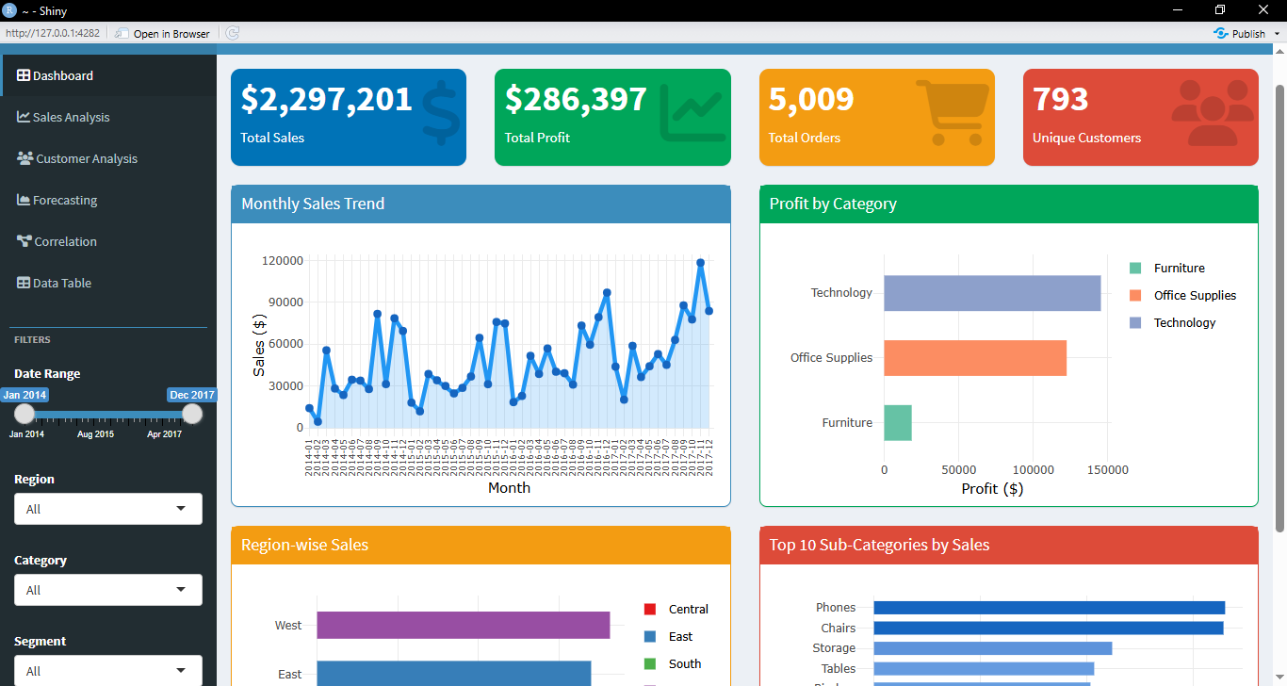

8.1 Overall KPIs (Full Dataset)
$2,297,201  Total Sales | $286,397  Total Profit | 5,009  Total Orders | 793  Unique Customers

Overall Profit Margin: 12.47%

8.2 Regional Performance
Region | Total Sales | % Share
West | $725,458 | 31.6%
East | $678,781 | 29.5%
Central | $501,240 | 21.8%
South | $391,722 | 17.1%

The West region leads in sales (31.6% share), followed closely by the East (29.5%). The South region contributes the least at 17.1%.

8.3 Top Sub-Categories by Sales
1. Phones | $330,007 - Highest-selling sub-category.
2. Chairs | $328,449 - Close second; high-ticket furniture items.
3. Storage | $223,844 - Consistent demand across all segments.
4. Tables | $206,966 - Notable for frequent negative-profit transactions due to heavy discounting.
5. Binders | $203,413 - Office supplies staple with high order frequency.

8.4 Discount vs. Profit Analysis
- Products with a discount rate above 40% frequently show negative profit margins.
- The Technology category maintains better margins even at moderate discount levels compared to Furniture.
- The Furniture category (especially Tables) suffers the largest losses when heavy discounts are applied.

8.5 Customer Segments
- Consumer segment accounts for the largest share of revenue (~50%).
- Corporate segment contributes approximately 30% and shows higher average order values.
- Home Office is the smallest segment (~20%) but often exhibits higher per-order profitability.

8.6 Sales Trend & Seasonality
- Monthly sales show a clear upward trend from 2014 to 2017.
- Sales consistently spike in November–December each year, indicating strong year-end demand (holiday season).
The ARIMA forecast projects continued growth with a moderate confidence interval for the next 12 months.
9. Conclusion
This project successfully demonstrates the development of a comprehensive, interactive business intelligence dashboard using R Shiny. The Superstore Sales Dashboard translates 9,994 raw retail transactions into six purposeful analytical views - from high-level KPI monitoring to granular customer analysis, time-series forecasting, and statistical correlation - all driven by real-time sidebar filters.
Key takeaways from the analysis include: the West region leads in revenue; Phones and Chairs are the top-selling sub-categories; high discount rates consistently erode profitability (especially in Furniture); and the Consumer segment drives approximately half of all sales. The ARIMA model confirms an upward sales trajectory, supporting the business case for continued investment.
The project demonstrates practical proficiency in R Shiny architecture (ui/server separation), reactive programming, ggplot2 visualization, time-series modelling, and professional dashboard design - skills directly applicable to real-world data analytics roles.

10. Future scope
- Add a date-range slider filter to enable period-specific analysis and year-over-year comparisons.
- Integrate a US choropleth map using the leaflet package to visualise state-level sales geographically.
- Implement a customer RFM (Recency, Frequency, Monetary) segmentation analysis tab.
- Add export buttons to download filtered data as CSV or generate a PDF summary report.
- Deploy the dashboard to shinyapps.io for public access without requiring a local R installation.
- Connect to a live database (e.g., PostgreSQL) to replace the static CSV with real-time transactional data.
Incorporate a product recommendation engine using collaborative filtering or market basket analysis.

